Value influences simultaneous competition for feature-based attention: Insights from Steady-State Visually Evoked Potentials

Ivan Grahek1☨*, Antonio Schettino1,2☨, Gilles Pourtois1, Ernst H.W. Koster1,

& Søren K. Andersen3

1. *Department of Experimental Clinical and Health Psychology, Ghent University, Henri Dunantlaan 2, B-9000, Ghent, Belgium*
2. *Institute for Globally Distributed Open Research and Education (IGDORE)*
3. *School of Psychology, University of Aberdeen, William Guild Building, Aberdeen, AB24 3FX, United Kingdom*

# Abstract

Keywords: attention; attentional control; EEG; feature-based attention; reward; motivation; steady-state visually evoked potentials; frequency tagging

# Introduction

Selective attention is crucial for adaptive behavior as it facilitates processing of relevant and suppression of irrelevant stimuli in our environment (Chun, Golomb, & Turk-Browne, 2011; Desimone & Duncan, 1995). This process depends on the physical salience of a stimulus (e.g., a loud noise) and on our current goals (e.g., searching for our keys; Corbetta & Shulman, 2002; Posner, 1980; Theeuwes, 2010). Recent research has pointed that motivation has an important influence on selective attention. Goal-driven attentional control is enhanced when individuals are motivated with extrinsic rewards (Botvinick & Braver, 2015; Pessoa, 2015). Attention can also be guided by previous reward history: stimuli which used to be associated with rewards can capture attention independently from top-down attentional control (Anderson, 2016; Awh, Belopolsky, & Theeuwes, 2012; Chelazzi, Perlato, Santandrea, & Della Libera, 2013; Failing & Theeuwes, 2017).

Goal-directed attention, as well as other cognitive control processes, is enhanced when individuals are anticipating that they can earn rewards for good task-performance (for a review see: Krebs & Woldorff, 2017). A number of fMRI and EEG studies have demonstrated that these reward-based enhancements in preparation for the upcoming stimulus are driven by enhanced activity in the frontoparietal regions crucial for attentional control (Krebs, Boehler, Roberts, Song, & Woldorff, 2012; Pessoa & Engelmann, 2010; Schevernels, Krebs, Santens, Woldorff, & Boehler, 2014), and by enhanced task-set representations in these areas (Etzel, Cole, Zacks, Kay, & Braver, 2016; Wisniewski, Reverberi, Momennejad, Kahnt, & Haynes, 2015). While these studies implicate the frontoparietal activity in reward-based improvements in attentional control, it remains unclear how the activity in these regions is translated into the enhanced processing of the relevant stimuli in the visual cortex.

Another set of studies has focused on the processing of stimuli previously related to rewards, often in situations in which the reward history is opposed to current goals (Anderson, 2016; Chelazzi et al., 2013; Failing & Theeuwes, 2017). Behavioral studies have found evidence for the involuntary attentional capture by stimuli which have previously been linked to rewards, which results in impaired task performance when such stimuli act as distractors (Anderson, Laurent, & Yantis, 2011; Della Libera & Chelazzi, 2009; Failing & Theeuwes, 2014). Studies focused on the neural mechanism of these effects have provided some evidence for the reward-related changes in the early stages of visual cortical processing (i.e., increase in the P1 component; Donohue et al., 2016; Hickey, Chelazzi, & Theeuwes, 2010; Luque et al., 2017; MacLean & Giesbrecht, 2015). However, other studies have failed to find evidence for such early modulations, and found changes in later stages of processing (increased N2pc component and improved decoding in later processing stages; Qi, Zeng, Ding, & Li, 2013; Tankelevitch, Spaak, Rushworth, & Stokes, 2019). Importantly, these studies have been able to assess the processing of only one feature at a time, for example the processing of a visual search display when it contains a high reward distractor. Thus it remains unclear how stimuli of different values simultaneously compete for attentional resources and at which level of visual processing the reward-history effects exert their effect.

Theoretical frameworks propose that the allocation of attention toward stimuli which are (or used to be) predictive of rewards is facilitated, while the processing of other stimuli is suppressed (Anderson, 2016; Awh et al., 2012; Chelazzi et al., 2013; Failing & Theeuwes, 2017). Further, Roelfsema and colleagues proposed that this effect relies on the plasticity of the visual cortex induced by the join effect of top-down attentional control and dopamine (Roelfsema, van Ooyen, & Watanabe, 2010). However, studies which have focused on neural processing of the stimuli related to rewards have mostly focused on them being either targets or distractors. Only one study to date has provided evidence for the enhanced representation of reward-related stimuli and suppression of the other stimuli. In an fMRI Hickey and Peelen (Hickey & Peelen, 2015) demonstrated that representations of objects paired with rewards were easier to decode from the object-selective visual cortex, while the representation of other objects were harder to decode.

In this study we sought to directly test the mechanism through which rewards influence goal-directed attention at the level of processing both targets and distractors. To this end, participants performed a random-dot kinematogram (RDK) task in which on each trial they had a goal to attend to either blue or red dots and detect their coherent movements. We investigated how the two stimulus features linked to different reward schedules simultaneously competed for attentional control in baseline, when individuals were able to earn extra monetary rewards (training phase), and when such rewards were no longer available (test phase). We recorded steady-state visual evoked potentials (SSVEPs) to track stimulus processing in the visual cortex. SSVEPs represent the oscillatory response of the visual cortex to flickering stimuli (Norcia, Appelbaum, Ales, Cottereau, & Rossion, 2015). They provide a continuous measure of feature-based attention deployed across multiple stimuli simultaneously, and are a reliably modulated by goal-directed attention in the paradigm which we used (Andersen & Müller, 2010). Crucially, different stimuli can be tagged with different frequencies allowing for the simultaneous measurement of the amount of attention allocated to each of the stimulus features.

This design enabled us to investigate two main questions. First, on each trial participants had a goal to attend to either blue or red dots, which meant that in the training and test phase the feature linked to high rewards was the target on some trials and the distractor on others. This allowed us to investigate how stimuli of different values simultaneously compete for goal-directed attention. Second, in the test phase individuals were no longer able to earn rewards. This allowed us to test how previous, but no longer relevant, stimulus values interact with goal-directed attention. In both cases there are several mechanisms through which reward-based effects can emerge based (Chelazzi et al., 2013; Failing & Theeuwes, 2017; Roelfsema et al., 2010). They can result from the improved processing of the targets (facilitation), reduced processing of the distractors (suppression), or both. Crucially, the incentive-based enhancement of goal-directed attention can be the product of facilitated processing of the high value stimuli and/or the suppression of the processing of the low value stimuli.

# Methods

## Participants

We tested 48 participants with normal or corrected-to-normal vision and no history of psychiatric or neurological disorders. Four participants were excluded due to technical problems during recording. Thus, the final data set consisted of 44 participants (30 females, 14 males; median age = 22). Participants received a fixed payoff of 20 €, plus up to 6 € extra as performance-contingent monetary rewards (on average 25.5 €). The study was approved by the ethics committee of Ghent University.

## Stimuli and task

We used the Random Dot Kinematogram (RDK) task (Andersen & Müller, 2010; Figure 1A), in which participants were presented with two overlapping circular RDKs of isoluminant colors (red and blue) on a grey background. Viewing distance was fixed with a chinrest at 55 cm from the 21-inch CRT screen (resolution of 1024 x 768 pixels, 120 Hz refresh rate). At the beginning of each trial, participants were instructed which of the two RDKs to attend by a verbal audio cue: “red” (241 ms) or “blue” (266 ms). The two RDKs had a diameter corresponding to 20.61 degrees of visual angle and consisted of 125 randomly and independently moving dots each (0.52 degrees of visual angle per dot). The two RDKs flickered at a different frequencies (10 or 12 Hz). One-third of trials contained one, two, or three coherent motion intervals, occurring with equal probability in the attended (targets) or unattended (distractors) color RDK. During these intervals, dots in one of the RDKs moved with 75% coherence in one of four cardinal directions (up, down, left, or right) for 300 ms. Participants had to detect the coherent movement as fast as possible by pressing the space key on a standard AZERTY USB keyboard. Response time was limited to 1,500 ms post-RDK onset and no response was recorded before 200 ms. Correct responses were followed by a tone (200 ms sine wave of either 800 or 1,200 Hz, counterbalanced across participants). Late or incorrect responses were followed by an error sound (200 ms square wave tone of 400 Hz).

The experiment started with 4 practice blocks of 60 trials. After each block, participants received feedback on their performance. After finishing the practice phase, participants completed 12 blocks of 50 trials divided into 3 phases (*baseline*, *training*, and *test*; *Figure 1B*). Each phase contained 100 trials on which participants were instructed to attend to the red color and 100 trials in which they were instructed to attend to the blue color. Out of those 100 trials, 40 trials contained no dot motion, and 60 trials contained one, two, or three dot motions (120 motions in total). During baseline, participants were simply doing the described task. In the training phase, the task was identical but participants could earn additional monetary rewards (up to 6 €) based on their performance. They were instructed that one of the colors would be paired with high probability (80%) and the other color with low probability (20%) of earning 10 extra cents for each correct detection. The mapping between color and reward probability was counterbalanced across participants. The receipt of the reward was signaled by a new tone that replaced the usual correct tone. If the correct tone was a sine wave of 800 Hz, the reward tone was a sine wave of 1,200 Hz and vice versa. At the end of each of the 4 blocks of the training phase, participants got feedback on both their performance and the amount of extra money earned within the block. The third phase (test) was identical to baseline (i.e., no monetary rewards assigned). The whole task lasted for approximately 50 minutes, including a short break in between blocks. After completing the task, participants filled in two questionnaires aimed at assessing their reward sensitivity (BIS-BAS; Franken et al., 2005) and depression levels (BDI-II; Van der Does, 2002). The questionnaire data is not reported here. This experiment was realized using Cogent 2000 developed by the Cogent 2000 team at the FIL and the ICN and Cogent Graphics developed by John Romaya at the LON at the Wellcome Department of Imaging Neuroscience.

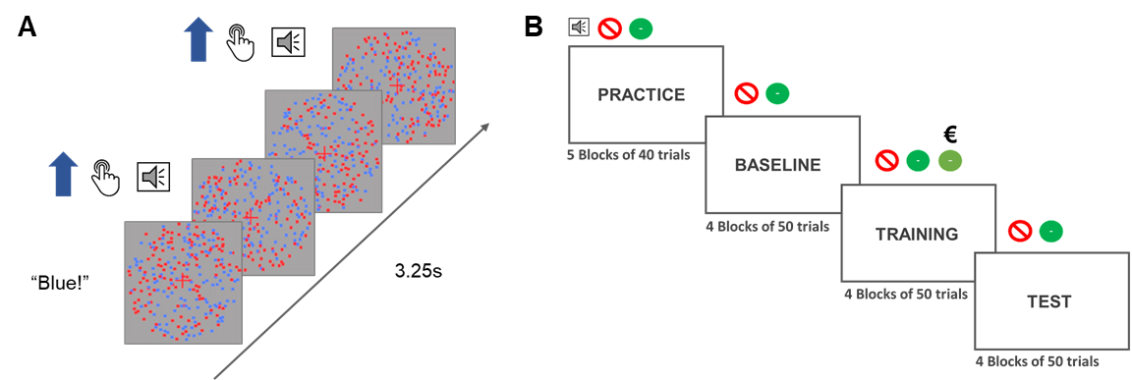

**Figure 1. Depiction of a signle trial and the phases of the experiment. A)** Each trial started with an audio cue (”Blue” or ”Red”) which instructed participants which color to attend to in that trial. The trial lasted for 3.25 seconds during which dots of either of the colors could move from 0 to 3 times. If the participants were instructed to attend to the blue dots and the blue dots moved coherently participants should have pressed the response button. In that case they would hear the auditory feedback signaling the correct detection of the movements. **B)** The experiment started with a practice and a baseline block in which the participants heard an audio cue at the begginning of the trial and two types of feedback sounds (incorrect or correct). In the training block a third sound was introduced to signal that the participants were both correct and received a reward for that response. They would still at times hear the the old correct feedback which would signal that they were correct, but not rewarded. The test phase was the same as the baseline phase.

## EEG recording and data pre-processing

Electroencephalographic activity (EEG) was recorded with an ActiveTwo amplifier (BioSemi, Inc., The Netherlands) at a sampling rate of 512 Hz. Sixty-four Ag/AgCl electrodes were fitted into an elastic cap, following the international 10/10 system (Chatrian, Lettich, & Nelson, 1985). The common mode sense (CMS) active electrode and the driven right leg (DRL) passive electrode were used as reference and ground electrodes, respectively. Additional external electrodes were applied to the left and right mastoids, as well as on the outer canthi of each eye and in the inferior and superior areas of the left orbit (to record horizontal and vertical electrooculogram, EOG).

Data pre-processing was performed offline with custom MATLAB scripts and functions included in EEGLAB v14.1.1b (Delorme & Makeig, 2004). After subtracting the mean value of the signal (DC offset), the continuous EEG data were epoched between 0 and 3,250 ms, corresponding to the beginning and end of the RDK trial, respectively. After referencing to *Cz*, FASTER v1.2.3b (Nolan, Whelan, & Reilly, 2010) was used for artifact identification and rejection using the following settings: (i) over the whole normalized EEG signal, channels with variance, mean correlation, and Hurst exponent exceeding *z* = ±3 were interpolated via a spherical spline procedure (Perrin, Pernier, Bertrand, & Echallier, 1989); (ii) the mean across channels was computed for each epoch and, if amplitude range, variance, and channel deviation exceeded *z* = ±3, the whole epoch was removed; (iii) within each epoch, channels with variance, median gradient, amplitude range, and channel deviation exceeding *z* = ±3 were interpolated; (iv) grand-averages with amplitude range, variance, channel deviation, and maximum EOG value exceeding *z* = ±3 were removed; (v) epochs containing more than 12 interpolated channels were discarded. All remaining epochs were scanned with SCADS (Junghöfer, Elbert, Tucker, & Rockstroh, 2000) and rejected when flagged as containing residual artifacts. For details, see our commented code at https://osf.io/5hryf/. After pre-processing, the average number of interpolated channels was 3.61 (*SD* = 1.23, range 1 – 6) and the mean percentage of rejected epochs was 8.77% (*SD* = 6.71, range 0 – 27.78). After re-referencing to averaged mastoids, trials in each condition were averaged separately for each participant, resulting in the following grand-averages: (i) baseline, red attended; (ii) baseline, blue attended; (iii) training, red attended; (iv) training, blue attended; (v) test, red attended; (vi) test, blue attended.

Electrodes with maximum SSVEP amplitudes were identified by calculating isocontour voltage maps based on grand-averaged data collapsed across all conditions. After removing linear trends, Fast Fourier Transforms on the EEG signal in a time window from 500 ms (to exclude the typically strong phasic visual evoked response to picture onset) to 3,250 ms after stimulus onset was applied, and amplitudes were obtained by extracting the absolute values of the resulting complex Fourier coefficients. We extracted SSVEP amplitude at 10 and 12 Hz from each individual electrode cluster, separately for each condition (averaged across trials). The amplitudes were normalized for each participant and frequency separately by dividing amplitudes by the average amplitude of the two conditions in the baseline. To account for inter-individual variations in topographical SSVEP amplitude distributions, we identified and averaged activity from the four electrodes displaying, for each participant, the largest frequency-specific amplitude.

For the behavioral data, reaction times of correct detections and sensitivity were analyzed. The analyses were done on the averaged data for each participant and condition. Sensitivity index d` (Macmillan & Creelman, 2004) was calculated with adjustments for extreme values (Hautus, 1995) using the *psycho* R package (for the method see: Pallier, 2002).

## Statistical analyses

Behavioral and EEG data were analyzed using Bayesian multilevel regressions. We fitted and compared multiple models of varying complexity to predict sensitivity (d`), reaction times for correct responses, and SSVEP amplitudes. Each of the fitted models included both constant and varying effects (also known as fixed and random). Participant-specific characteristics are known to affect both behavioral performance (e.g., response speed) and EEG signal (e.g., skull thickness, skin conductance, hair); therefore, we decided to model this variability by adding varying intercepts in our models. Additionally, the studied effects (e.g., reward sensitivity and selective attention) are known to vary in magnitude over participants, so we opted for including varying slopes in our models. It should be noted that, because of the simultaneous estimation of group-level and participant-level parameters, multilevel models display a property called *shrinkage*. In brief, estimates that strongly deviate from the mean (e.g., a participant performing the task much worse than the average of the total sample) will be pulled toward the group mean (McElreath, 2016). This advantageous property prevents extreme values from having large effects on the results.

Models were fitted in R using the *brms* package (Bürkner, 2016) which employs the probabilistic programming language *Stan* (Carpenter et al., 2016)to implement Markov Chain Monte Carlo (MCMC) algorithms in order to estimate posterior distributions of the parameters of interest (details about the fitted models can be found in the data analysis scripts). Each of the models were fitted using weakly informative prior distributions (described below) and Gaussian likelihood. Four MCMC simulations (“chains”) with 6,000 iterations (3,000 warmup) and no thinning were run to estimate parameters in each of the fitted models. Further analyses were done following the recommendations for Bayesian multilevel modeling using *brms* (Bürkner, 2016, 2017; Nalborczyk & Bürkner, 2019). We confirmed that all models converged by examining trace plots, autocorrelation, and variance between chains (Gelman-Rubin statistic; Gelman & Rubin, 1992). We compared models based on their fit to the actual data using the Bayesian *R*2 (Gelman, Goodrich, Gabry, & Ali, 2017), and their out-of-sample predictive performance using the Widely Applicable Information Criterion (WAIC; Watanabe, 2010). The best model was selected and the posterior distributions of conditions of interest were examined. Differences between conditions were assessed by computing the mean and the 95% highest density interval (HDI) of the difference between posterior distributions of the respective conditions (Kruschke, 2014). Additionally, we calculated the evidence ratios (ERs) for our hypotheses as the ratios between the percentage of posterior samples on each side of the zero of a difference distribution between two conditions. ERs can be interpreted as the probability of a hypothesis (e.g. “Condition A is larger than condition B”) against its alternative (“Condition B is larger than condition A”).

# Results

## Behavioral results

We fitted three models to predict sensitivity (d`) and reaction times (in milliseconds) separately (*Figure 2* for the raw data and *Supplementary Table 1* for the descriptive statistics). First, we fitted the *Null model* with a constant and varying intercepts across participants. This model was fitted in order to explore the possibility that the data would be best explained by simple random variation between participants. To investigate the effect of reward phase (baseline, training, test), we fitted the *Reward phase* model which included only reward phase as the constant predictor, as well as varying intercepts and slopes across participants for this effect. To investigate the possible interaction between reward phase and reward probability, we fitted the *Reward phase * Reward probability* model including the intercepts and slopes of these two effects and their interaction as both constant and varying effects. All models had a Gaussian distribution as the prior for the intercept (for sensitivity: centered at 1.8 with a standard deviation of 1; for reaction times: centered at 500 with a variance of 200). The models with slopes also included a Gaussian distribution as the prior for the slopes (for sensitivity: centered at 0 with a standard deviation of 2; for reaction times: centered at 0 with a standard deviation of 200). These weakly informative priors were chosen based on the previous study which used the same task (Andersen & Müller, 2010). Note that there are two additional models that, although possible to fit, are not plausible in the context of our experiment. Specifically, the model with only the effect of reward probability overlooks the fact that this effect would necessarily be most pronounced in the training phase, thus interacting with the effect of reward phase. The same logic applies to the model with additive effects of reward phase and probability (i.e., these effects could not act independently in our experimental design).

### Sensitivity

Of all the tested models, the *Reward phase * Reward probability* model best predicted sensitivity (*Table 1*). This result points to the importance of the interaction between reward phase and reward probability in predicting sensitivity. The posterior distributions of the interaction model (*Figure 2A* and *Table 2*) revealed that sensitivity improved in the training phase compared to the baseline for low rewarded feature (*M =* 0.18; 95% HDI [0.06, 0.31]; ER = 499.00), but only slightly for the high rewarded feature (*M =* 0.04; 95% HDI [-0.08, 0.17]; ER = 2.92). This improvement was far more pronounced for low compared to high reward probability (*M =* 0.14; 95% HDI [-0.03, 0.31]; ER = 17.18). Conversely, there was no evidence for the difference between training and test phases in the low (*M =* 0.00; 95% HDI [-0.13, 0.13]; ER = 1.08), and only a very small reduction in sensitivity in the high rewarded condition (*M =* -0.03; 95% HDI [-0.16, 0.11]; ER = 2.42). These results suggest that participants were more sensitive in detecting the movements of the targets in the training phase compared to baseline, and far more so for the low rewarded color. There was also very little evidence of a change in their sensitivity from the training to the test phase.

|  |  |  |  |  |
| --- | --- | --- | --- | --- |
| Table 1  *Mean and standard errors (in parenthesis) of WAIC and Bayesian R2 for each model predicting sensitivity and reaction times.* | | | | |
| Model | | *WAIC (SE)* | | *Bayesian R2 (SE)* |
| *Sensitivity* | | | | |
| Null | | 446.33 (23.43) |  | 0.22 (0.05) |
| Reward phase | | 451.47 (22.74) |  | 0.24 (0.05) |
| Reward phase * Reward probability | | 200.57 (21.27) |  | 0.76 (0.22) |
| *Reaction times* |
| Null | | 2,541.30 (26.80) |  | 0.58 (0.03) |
| Reward phase | | 2,511.86 (27.49) |  | 0.64 (0.03) |
| Reward phase * Reward probability | | 2,324.94 (23.46) |  | 0.87 (0.02) |

|  |  |  |  |
| --- | --- | --- | --- |
| Table 2  *Means and 95% HDIs of the posterior distributions of reaction times and sensitivity in each condition.* | | | |
| Reward phase | Reward probability | Sensitivity (d`) | Reaction times (milliseconds) |
| Baseline | High | 1.74 [1.55, 1.90] | 551.15 [538.76, 563.40] |
| Baseline | Low | 1.50 [1.31, 1.69] | 556.82 [543.65, 570.10] |
| Training | High | 1.78 [1.59, 1.96] | 528.87 [516.89, 541.25] |
| Training | Low | 1.68 [1.49, 1.87] | 542.01 [530.03, 554.53] |
| Test | High | 1.75 [1.58, 1.93] | 533.06 [518.87, 547.36] |
| Test | Low | 1.68 [1.49, 1.87] | 540.89 [526.07, 555.71] |

**Figure 2. Raw and modelled data.** Violin plots displaying raw data for each participant (grey dots), separately for each condition. Results from the winning models are presented in blue (dark blue – 50% HDIs and light blue – 95% HDIs). **A)** Sensitivity (*d`*) **B)** Reaction times (ms) **C)** SSVEP amplitudes (arbitrary units) in response to the color related to high reward probability on trials in which it acts as target or distractor. **D)** SSVEP amplitudes for the color linked to low rewards on trials when it acts as target or distractor.

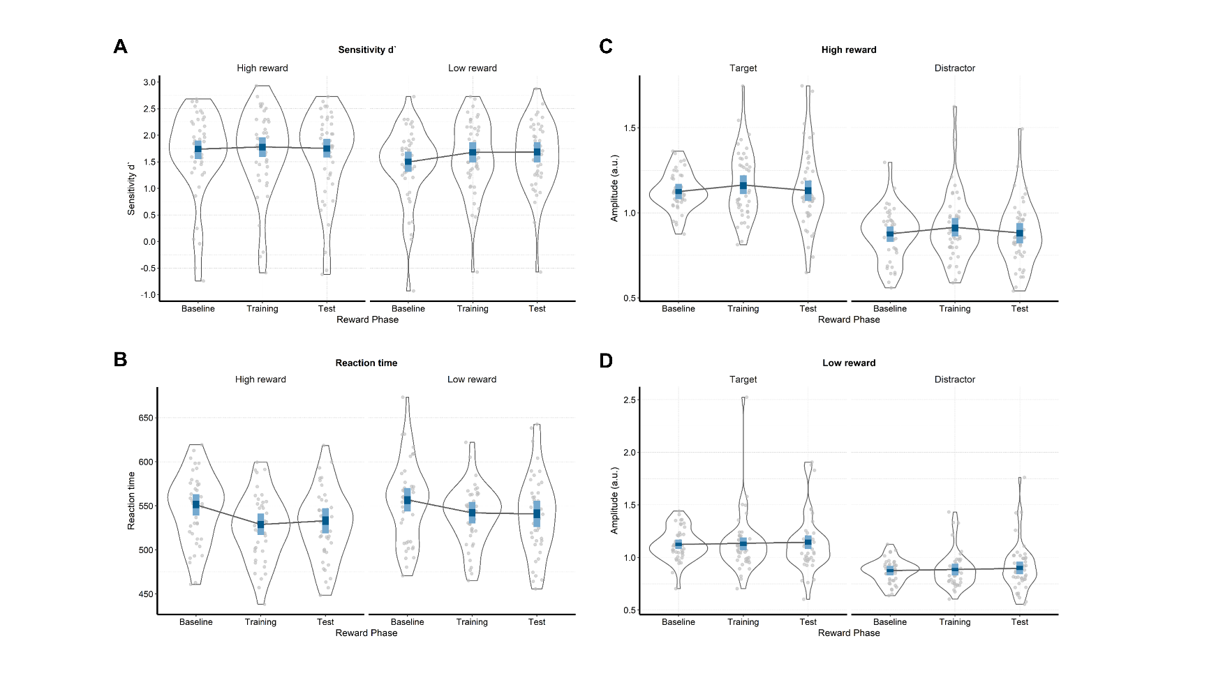

### Reaction times

The *Reward phase * Reward probability* model also best predicted the reaction times (*Figure 2B* and *Table 1*). Participants were reliably faster in the training compared to the baseline phase in both the high rewarded (*M =* -22.30; 95% HDI [-30.30, -14.40]; ER = *Inf.*, i.e. the whole posterior distribution was below zero) and the low rewarded conditions (*M =* -14.80; 95% HDI [-22.80, -6.52]; ER = *Inf.*). Moreover, this difference was larger in the high compared to low rewarded condition (*M =* -7.46; 95% HDI [-16.50, 1.99]; ER = 16.24). We found less evidence for changes in reaction times between the training and the test phase. There was a very small increase in the reaction times in the test compared to training phase in the high reward condition (*M =* 4.19; 95% HDI [-3.94, 11.80]; ER = 5.62), and there was no difference in the low reward condition (*M =* -1.12; 95% HDI [-9.11, 6.68]; ER = 1.59). These results indicate that participants were faster in the condition in which they could earn rewards (training), and more so in the condition with higher probability of earning a reward. Also, there was a very small increase in the reaction times for the high reward condition and no difference in the low reward condition when the rewards were no longer available (test). Supplementary analyses carried out to assess possible training effects indicated some evidence for the presence of training effects in sensitivity and scant evidence for such effects in reaction times (*Supplementary materials*).

## SSVEP amplitudes

As shown in *Figure 3* activity averaged over conditions was mainly localized at central occipital channels (i.e., *Oz*, *POz*, *O2*, *PO3*). Also, the FFT-amplitude spectra showed the expected peaks at the frequencies of 10 and 12 Hz.

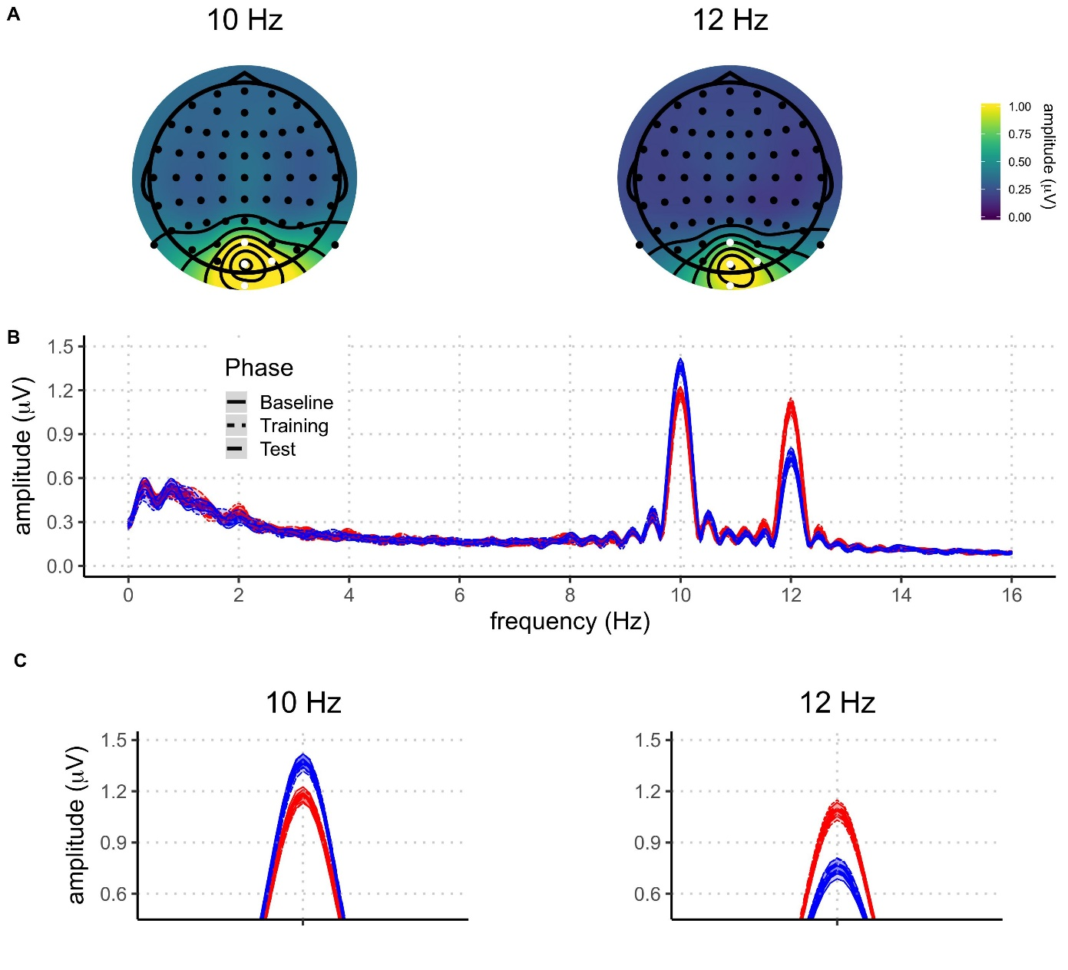

**Figure 3.** **A)** Topographies of SSVEP amplitude, averaged across all participants and conditions, at 10 Hz and 12 Hz. Electrodes selected for the analysis are highlighted in white. **B)** Grand average amplitude spectra derived from EEG signals at each participant’s best four-electrode cluster for the different experimental conditions (blue: attended; red: unattended; solid: baseline phase; dotted: rewarded phase; dashed: non-rewarded phase). The shaded areas around the means indicate 95% confidence intervals.

We fitted seven models to predict the trial-averaged SSVEP amplitudes (in a.u. due to the normalization) across conditions (*Figure 2C, Figure 2D,* and *Supplementary* *Table 2*). The *Null model* included one constant and multiple varying intercepts across participants. The *Attention model* included the constant effect of attention; the *Reward Phase model* included the constant effect of reward phase; the *Reward Phase + Attention* model included the additive effects of reward phase and attention; and the *Reward Phase * Attention* model also included the interaction between reward phase and attention. The *Reward probability * Reward phase + Attention* model consisted of the constant effects of reward probability and phase, their interaction, and the independent effect of attention. The last model was the *Reward probability * Reward phase * Attention* model which included all constant effects and their interaction. All models, except for the *Null* *model*, included varying intercepts and slopes across participants for all of the constant effects. All models included a Gaussian distribution as the prior for the intercept (centered at 1 with a standard deviation of 3). In addition, the models with slopes included a Gaussian distribution as the prior for the slopes (centered at 0 with a standard deviation of 3). These weakly informative priors were chosen based on the previous study with the same task (Andersen & Müller, 2010). As was the case for the behavioral data, several models were not fitted because they were not plausible in the context of our experiment (e.g., the models that include both reward phase and probability, but not their interaction).

The *Reward probability * Reward phase + Attention* model best predicted SSVEP amplitudes across conditions (*Table 3*). However, the *Reward probability * Reward phase * Attention* was only slightly worse than the winning model. Here we draw inferences from the winning model, but note that the conclusions do not substantially change when analyzing the model which includes the three-way interactions. The analysis of the posterior distributions of the winning model (*Figure 2* and *Table 3*) revealed a strong effect of attention: in all conditions, SSVEP amplitudes were higher for the attended (target) compared to the unattended (distractor) stimuli. In the winning model the size of the difference of the SSVEP amplitudes related to the processing of the targets and distractors did not interact with the other factors in the model. The posterior distribution of the difference between target and distractor stimuli did not include zero, thus resulting in infinite probability that the target stimuli would elicit higher SSVEP amplitudes compared to the distractor ones (*M =* 0.25; 95% HDI [0.20, 0.30]; ER = *Inf*). These results reveal a very robust effect of goal-directed attention across all experimental conditions: the SSVEP amplitudes were always higher for the targets compared to distractors.

|  |  |  |  |
| --- | --- | --- | --- |
| Table 3  *Model comparison indices for EEG results* | | | |
| Model | *WAIC (SE)* |  | *Bayesian R2 (SE)* |
| Null | 65.34 (62.67) |  | 0.08 (0.02) |
| Reward phase | 16.17 (59.31) |  | 0.14 (0.02) |
| Attention | -341.85 (70.91) |  | 0.40 (0.02) |
| Reward phase + Attention | -428.76 (67.19) |  | 0.46 (0.02) |
| Reward phase * Attention | -424.98 (67.36) |  | 0.46 (0.02) |
| Reward probability * Reward phase + Attention | -647.37 (74.90) |  | 0.59 (0.01) |
| Reward phase * Reward probability * Attention | -638.31 (74.97) |  | 0.59 (0.01) |
|  | | | |

|  |  |  |  |
| --- | --- | --- | --- |
| Table 4  *Means and 95% HDIs of the posterior distributions of the SSVEP amplitudes for each condition.* | | | |
| Attention | Reward phase | Reward probability | Amplitudes (a.u.) |
| Target | Baseline | High | 1.12 [1.08, 1.17] |
| Target | Baseline | Low | 1.12 [1.08, 1.17] |
| Target | Training | High | 1.16 [1.11, 1.22] |
| Target | Training | Low | 1.13 [1.07, 1.19] |
| Target | Test | High | 1.13 [1.07, 1.19] |
| Target | Test | Low | 0.90 [0.84, 0.96] |
| Distractor | Baseline | High | 0.88 [0.83, 0.92] |
| Distractor | Baseline | Low | 0.87 [0.83, 0.92] |
| Distractor | Training | High | 0.91 [0.86, 0.97] |
| Distractor | Training | Low | 0.89 [0.83, 0.94] |
| Distractor | Test | High | 0.88 [0.82, 0.94] |
| Distractor | Test | Low | 0.90 [0.84, 0.96] |

The winning model also included the interaction between reward phase and reward probability, but this interaction remained the same for both targets and distractors. The SSVEP amplitudes were higher in the training phase than in the baseline for the high reward feature (*M = -*0.04; 95% HDI [-0.09, 0.01]; ER = 15.13), both when it acted as a target and as a distractor. However, there was no evidence of difference for the change in the SSVEP amplitudes from baseline to training for the low reward feature (*M = -*0.01; 95% HDI [-0.06, 0.04]; ER = 2.02). Comparing the training to the test phase, the amplitudes of the high reward feature were reduced (*M = -*0.01; 95% HDI [-0.06, 0.04]; ER = 15.66), while the amplitudes of the low reward feature did not change (*M =* 0.01; 95% HDI [-0.04, 0.05]; ER = 2.17). To summarize, the amount of attention allocated toward the high reward feature increased in the phase in which participants could earn monetary rewards and went back to the baseline level in the phase in which no more rewards could be earned. However, the amount of attention allocated toward the low rewarded feature remained constant throughout the experiment.

# Discussion

In this study we investigated the neural mechanisms through which rewards enhance goal-directed attention. We compared the amount of attention allocated toward targets and distractors of different values. Compared to baseline, the introduction of rewards improved detection sensitivity and reaction times in the random dot kinematogram task. Further, dots linked to higher reward probability were detected faster, which was accompanied by an increased amount of attention allocated toward these stimuli, as measured by the amplitude of the corresponding SSVEP. This was true both when the high reward feature was a target and a distractor. When rewards were no longer available the amount of attention went back to baseline levels, but participants were still faster to detect the movement of the high value targets. These findings have several important implications for the understanding of the relationship between motivation and goal-directed attention.

Our behavioral findings are in line with studies showing the incentive-based improvements in attentional control (Krebs et al., 2012; Padmala & Pessoa, 2011). These results are also similar to those of the studies which explored the influence of previous but no longer relevant reward associations on attention. Such studies typically find that stimuli previously related to high rewards involuntarily capture attention, which is demonstrated by the increased reaction times in visual search and spatial cueing tasks on trials when these stimuli act as distractors (Anderson, Laurent, & Yantis, 2011; Della Libera & Chelazzi, 2009; Failing & Theeuwes, 2014). While these studies usually use two different tasks in the training and the test phase, here we show comparable results within a single task. Our participants were faster to detect dot movements when the feature linked to high rewards was a target compared to the trials on which this feature was a distractor. This difference was present both in the phase when participants could earn rewards, but also in the phase in which they were aware that no more rewards could be earned. This persistent effect can be understood as the long-lasting effect of reward history on selective attention, even when this effect is in opposed to the current goals of the participant (Anderson, 2016; Failing & Theeuwes, 2017).

At the neural level, we have directly replicated the finding that the SSVEP amplitudes are strongly influenced by goal-directed attention (Andersen, Müller, & Hillyard, 2012; Andersen & Müller, 2010). Across all of the phases of the experiment, the SSVEP amplitudes in the frequency of the target stimuli were higher than the amplitudes in the frequency of the distractors. This robust effect was modulated by reward. Model comparisons have provided evidence that the models which take into account the reward manipulation account for the data much better than the model which includes only the effect of goal-directed attention. This result is in line with the previous findings using fMRI (Krebs et al., 2012; Pessoa & Engelmann, 2010) and EEG (Schevernels et al., 2014) which have demonstrated that rewards enhance attentional control. Our findings also corroborate the theoretical models which posit motivation as being a crucial factor in the control of attention (Brown & Alexander, 2017; Holroyd & McClure, 2015; Shenhav, Botvinick, & Cohen, 2013; Verguts, Vassena, & Silvetti, 2015).

Crucially, our experiment allowed us to better understand the mechanisms through which rewards influence goal-directed attention. While previous studies have mostly focused on the influence of rewards on preparatory attentional control, we have been able to probe the mechanisms through which this improvement operates at the level of processing the stimuli in the task. Our results indicate that the enhancement in goal-directed attention comes from the facilitated processing of stimuli linked to high reward probability. This facilitation is likely localized in the V1-V3 areas of the visual cortex, in which the attentional modulation of the SSVEP signal in the current paradigm occurs (Andersen & Müller, 2010; Andersen, Hillyard, & Müller, 2008). It is likely that the enhanced anticipatory frontoparietal activity reported in fMRI studies of reward attention (Krebs & Woldorff, 2017) leads to the increase in the processing of reward-related targets in the visual cortex which we observe. Our finding is in line with the previous fMRI studies indicating improved processing of stimuli linked to high rewards (Hickey & Peelen, 2015; Serences, 2008). Importantly, the facilitated processing of the high value feature linked was present both when that feature is a target and a distractor. When the high reward feature was a distractor, the facilitated processing of the feature was in collision with the goal to attend to the other feature. This finding is in line with the theories proposing that reward associations can counteract top-down attentional control (Chelazzi et al., 2013; Anderson, 2016; Failing & Theeuwes, 2018). Notably, facilitated processing of the distractor in this case did not lead to worse or slower detection of the targets compared to baseline. However, participants were slower in detecting the movement of the targets on these trials compared to the trials on which the targets were the high rewarded feature.

Our paradigm allowed us to simultaneously measure the processing of stimuli linked to both high and low value. Some initial evidence for the suppression of the stimuli linked to low compared to high rewards has been found at the behavioral and neural level (Hickey & Peelen, 2015; Padmala & Pessoa, 2011). Suppression of the features linked to low or no rewards has also been proposed as one of the potential mechanisms through which incentives impact attention (Chelazzi et al., 2013; Anderson, 2016; Failing & Theeuwes, 2018). In this study we have not found evidence for this proposal. Suppression was not present neither when the low reward feature was presented as a target, nor when it was presented as a distractor. The amount of attention allocated toward this feature remained unchanged throughout the experiment. There are two features of our experiment which could explain this finding. First, in our experiment both of the stimuli features were related to rewards, but they differed in reward probability. For example, the study which showed evidence for the suppression of the non-rewarded feature did so in the context in which suppression occurred for the representations of objects which were never rewarded (Hickey & Peelen, 2015). In our paradigm it could be adaptive for participants not to suppress the low rewarded feature because correct responses to the movements of this feature would still earn them a reward on 20% of trials. Second, while the attended feature changed trial-by-trial in our experiment, the experiment of Hickey and Peelen consisted out of small blocks of 16 trials in which the attended feature was always the same (e.g., searching for a car in a complex picture). When searching for one object or feature across a number of future trials, it is possible that the optimal solution for the cognitive system is to suppress the processing of the other features or objects (i.e., distractors). However, if the attended feature is likely to change on each trial, as in our experiment, the suppression of the low rewarded feature could be maladaptive as it would carry a cost of reconfiguring the control signals on every trial (for a computational implementation of a reconfiguration cost see: Musslick, Shenhav, Botvinick, & Cohen, 2015). Both of these explanations could be tested within our experimental paradigm. Replacing the low rewarded feature with a no-reward feature, or introducing small blocks could lead to a better understanding of the boundary conditions of attentional suppression in the context of rewards.

In the test phase the behavior displayed the similar patterns as in the training phase. Individuals were faster to detect movements of the dots in color related to high reward probability. This finding follows the reward-history effects reported in several paradigms (Anderson, Laurent, & Yantis, 2011; Della Libera & Chelazzi, 2009; Failing & Theeuwes, 2014). However, our results show that the amount of attention allocated toward the high value feature was the same in the test phase as in the baseline. This result indicates that the longer lasting effect of reward history was not mediated by attention as measured by the SSVEPs. A possible explanation for this finding is that our measure captures the more sustained aspect of attention, while the effects of reward-history on the visual processing rely on more transient attentional capture (Donohue et al., 2016; Hickey et al., 2010; Luque et al., 2017; MacLean & Giesbrecht, 2015). However, there are at least two studies which have not found evidence for the effects of reward history on the early visual processing (Qi et al., 2013; Tankelevitch et al., 2019). This leaves open the possibility that the effects of reward history are not necessarily driven by purely attentional mechanisms. One interesting possibility which should be explored in further studies is that rewards initially improve performance by enhancing attentional mechanisms, but later rely on more direct stimulus-response mappings. Finally, it is important to note that our study was not primarily designed to assess the reward-history effects. Although the number of trials in the training phase is approximately is similar to those in studies demonstrating reward history effects, we used the same task in the training and test phase, which is not common for such studies. In addition, our paradigm involves a cue on every trial inducing a direct goal which is not the case with most of the studies assessing the influence of reward-history on attention. Further research using SSVEPs in tasks designed to explicitly address the reward-history effects could help disentangle between the possible explanations of our findings.

In this electrophysiological study we investigated the simultaneous deployment of attention to stimuli of different values when they acted as either targets or distractors. Our results provide a novel insight into the flexible dynamics of attentional deployment based on value of different stimuli. They reveal the mechanism through which rewards can enhance goal-directed attention. First, we show that monetary rewards can enhance goal-directed attention. Further, we demonstrate that there is a facilitated processing of the feature linked to high rewards, both when it acts as a target and a distractor. Finally, this biased competition is no longer present once the rewards are no longer available. These results corroborate the importance of motivation in guiding attention (Botvinick & Braver, 2015; Chelazzi et al., 2013; Failing & Theeuwes, 2017; Pessoa, 2015), and provide a clear mechanisms through which motivation can influence attention in the visual cortex, which is in line with the existing models (Roelfsema et al., 2010). Finally, this study demonstrates the value of using the SSVEPs to investigate the simultaneous competition for attentional resources of stimuli of different values. This technique can be used to further test the existing theoretical models which relate attention and motivation. Crucially, this technique allows for measuring the processing of both targets and distractors, while dissociating between the effects of goal-driven attention and reward.

# Supplementary materials

**Means of the raw behavioral and SSVEP data**

|  |  |  |  |
| --- | --- | --- | --- |
| Supplementary Table 1  *Means and 95% HDIs (in square brackets) of the raw data for sensitivity and reaction times* | | | |
| Reward phase | Reward probability | Sensitivity (d`) | Reaction times (milliseconds) |
| Baseline | High | 1.65 [-0.04, 2.68] | 547.07 [485.64, 619.34] |
| Baseline | Low | 1.45 [ 0.04, 2.30] | 553.88 [480.45, 631.36] |
| Training | High | 1.69 [-0.29, 2.73] | 525.11 [467.12, 599.49] |
| Training | Low | 1.61 [ 0.46, 2.68] | 538.55 [465.32, 584.63] |
| Test | High | 1.62 [-0.20, 2.73] | 528.66 [457.08, 599.83] |
| Test | Low | 1.61 [ 0.74, 2.88] | 539.76 [455.80, 623.21] |

|  |  |  |  |
| --- | --- | --- | --- |
| Supplementary Table 2  *Means and 95% HDIs of the raw data for the recorded SSVEP amplitudes in each condition* | | | |
| Attention | Reward phase | Reward probability | Amplitudes (a.u.) |
| Target | Baseline | High | 1.13 [0.92, 1.52] |
| Target | Baseline | Low | 1.13 [0.86, 1.52] |
| Target | Training | High | 1.16 [0.80, 1.60] |
| Target | Training | Low | 1.13 [0.76, 1.71] |
| Target | Test | High | 1.13 [0.61, 1.61] |
| Target | Test | Low | 1.13 [0.59, 1.84] |
| Distractor | Baseline | High | 0.87 [0.47, 1.17] |
| Distractor | Baseline | Low | 0.87 [0.49, 1.11] |
| Distractor | Training | High | 0.91 [0.54, 1.38] |
| Distractor | Training | Low | 0.89 [0.50, 1.28] |
| Distractor | Test | High | 0.88 [0.48, 1.23] |
| Distractor | Test | Low | 0.91 [0.44, 1.42] |

**Additional analyses to assess the possible training effects**

In order to assess potential training effects on behavioral performance, we split each reward phase into two halves (*Supplementary Figure 1* and *Supplementary Table 3*). If training effects were influencing the behavioral outcome, we could expect performance improvement through baseline and training. To investigate this possibility, we fitted the *Reward phase * Reward probability* model that was identical to the one described in the results section. We then compared behavioral performance between the first and the second part of the baseline phase, and between the second part of baseline and the first part of training phase.

|  |  |  |  |
| --- | --- | --- | --- |
| Supplementary Table 3  *Means and 95% HDIs of the war data for sensitivity and reaction times across six phases of the experiment* | | | |
| Reward phase | Reward probability | Sensitivity (d`) | Reaction times (milliseconds) |
| Baseline1 | High | 1.49 [-0.36, 2.62] | 548.73 [479.43, 613.76] |
| Baseline1 | Low | 1.30 [ 0.09, 2.35] | 551.97 [458.26, 621.44] |
| Baseline2 | High | 1.60 [-0.27, 2.56] | 545.60 [454.56, 620.36] |
| Baseline2 | Low | 1.45 [ 0.08, 2.33] | 556.21 [486.84, 650.73] |
| Training1 | High | 1.56 [-0.08, 2.65] | 521.47 [437.90, 587.57] |
| Training1 | Low | 1.58 [ 0.47, 2.45] | 542.80 [463.65, 593.47] |
| Training2 | High | 1.59 [ 0.08, 2.56] | 528.96 [462.00, 598.58] |
| Training2 | Low | 1.47 [ 0.00, 2.62] | 534.72 [479.38, 618.25] |
| Test1 | High | 1.51 [-0.07, 2.57] | 528.30 [457.88, 596.17] |
| Test1 | Low | 1.49 [ 0.36, 2.50] | 536.86 [444.89, 621.00] |
| Test2 | High | 1.50 [-0.38, 2.49] | 528.92 [448.24, 606.00] |
| Test2 | Low | 1.53 [ 0.65, 2.55] | 542.76 [450.11, 617.44] |

The posterior distributions for sensitivity (*Supplementary Figure 1* and *Supplementary Table 4*) revealed performance improvement from the first to the second part of the baseline for both high (*M =* 0.11; 95% HDI [-0.04, 0.27]; ER = 11.19) and low (*M =* 0.15; 95% HDI [0.01, 0.31]; ER = 30.25) reward probability conditions. When comparing the second part of baseline to the first part of training, there was no difference in the high reward probability condition (*M =* 0.04; 95% HDI [-0.12, 0.21]; ER = 2.27). However, in the low probability condition, sensitivity increased in the first part of the training phase (*M =* 0.14; 95% HDI [-0.03, 0.29]; ER = 18.23). These results indicate that participants improved not only throughout the baseline phase, but also from the end of baseline to the first part of the training (albeit for low rewarded color only). This might indicate some presence of training effects in the sensitivity data.

The posterior distributions of reaction times (*Supplementary Figure 2* and *Supplementary Table 2*) revealed no differences between the first and the second part of baseline for neither high (*M =* -3.13; 95% HDI [-13.3, 7.28]; ER = 2.70) nor low reward probability condition, which was even somewhat slower in the second part of the baseline (*M =* 4.23; 95% HDI [-6.11, 14.90]; ER = 3.67). The comparison between the second part of baseline and the first part of training revealed a very reliable speeding in both high (*M =* 24.00; 95% HDI [13.40, 34.80]; ER = *Inf.*) and low (*M =* 12.86; 95% HDI [2.22, 24.10]; ER = 110.11) reward probability conditions. These results clearly point to the absence of training effects in reaction time data.

Taken together, these results indicate that our effects were not driven by the improved performance over the course of the task. Although there is some evidence that sensitivity was improving during the baseline phase, reaction times clearly indicate that the main shift in performance happens in the beginning of training, when rewards are introduced. Importantly, the strongest behavioral effects in our study were found on reaction time data, as indicated in the results section.

Similar analyses could not be performed for the EEG data, because splitting the number of trials in each phase would significantly affect the signal-to-noise ratio. However, our EEG results point to changes in SSVEP amplitudes in only one of the reward probability conditions. If amplitude changes were mainly driven by training effects, the differences across reward phases would be expected for both reward probability conditions. This observation, combined with the lack of strong training effects in behavior, suggests that our EEG results are not driven by training effects.

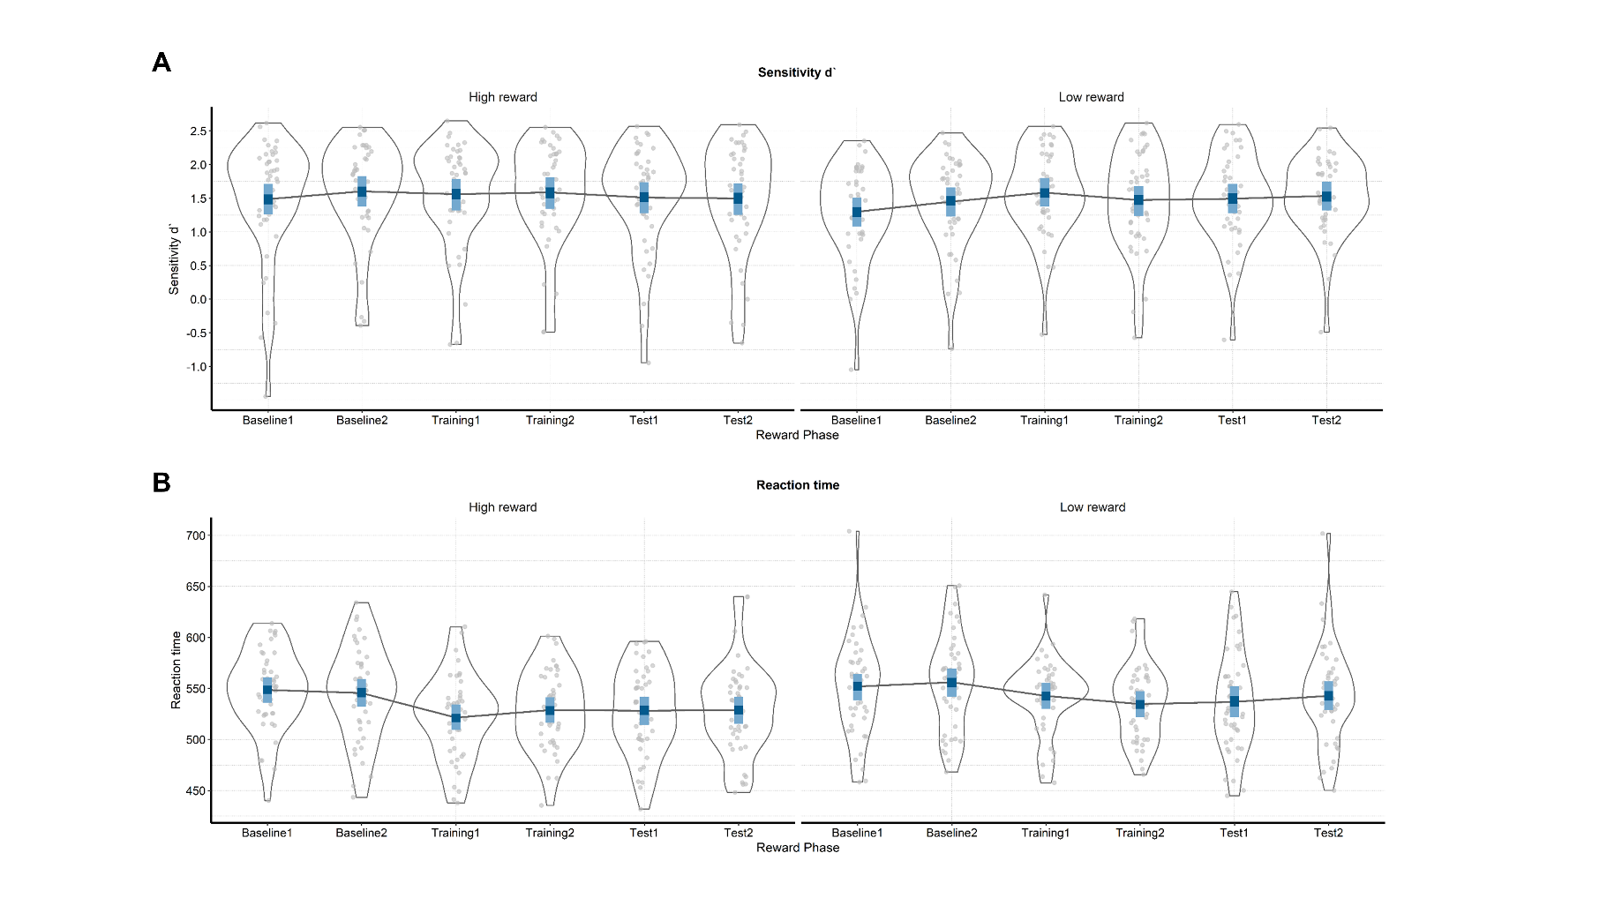

**Supplementary Figure 1. Raw and modelled behavioral data in each half of each phase of the experiment.** On both plots raw participant data is represented with grey dots and their distribution. The winning model is presented in blue (dark blue – 50% HDIs and light blue – 95% HDIs). **A)** Sensitivity (d`) across the phases of the experiment for the conditions in which the target color is linked to either high or low reward probability. **B)** Reaction times (ms) in the six phases when the target is related to high or low reward probability.

|  |  |  |  |
| --- | --- | --- | --- |
| Supplementary Table 4  *Means and 95% HDIs of sensitivity and reaction times across six phases of the experiment* | | | |
| Reward phase | Reward probability | Sensitivity (d`) | Reaction times (milliseconds) |
| Baseline 1 | High | 1.49 [1.26, 1.71] | 548.63 [535.91, 560.72] |
| Baseline 1 | Low | 1.30 [1.08, 1.51] | 551.89 [538.38, 564.15] |
| Baseline 2 | High | 1.60 [1.38, 1.83] | 545.50 [532.36, 559.34] |
| Baseline 2 | Low | 1.45 [1.23, 1.66] | 556.12 [542.01, 569.51] |
| Training 1 | High | 1.56 [1.32, 1.79] | 521.46 [509.29, 534.18] |
| Training 1 | Low | 1.58 [1.38, 1.80] | 542.74 [529.90, 555.54] |
| Training 2 | High | 1.59 [1.34, 1.81] | 528.94 [516.56, 541.59] |
| Training 2 | Low | 1.47 [1.24, 1.68] | 534.70 [521.78, 547.53] |
| Test 1 | High | 1.51 [1.28, 1.74] | 528.27 [514.43, 542.01] |
| Test 1 | Low | 1.49 [1.28, 1.71] | 536.87 [522.00, 552.32] |
| Test 2 | High | 1.50 [1.25, 1.72] | 528.92 [515.37, 542.04] |
| Test 2 | Low | 1.54 [1.32, 1.75] | 542.76 [528.68, 557.15] |

## Software for data visualization and analysis

Visualization and statistical analyses were performed using R v3.4.4 (R Core Team, 2017) via RStudio v1.1.453 (RStudio Team, 2015). We used the following packages (and their respective dependencies):

• data manipulation: tidyverse v1.2.1 (Wickham, 2017);

• statistical analyses: Rmisc v1.5 (Hope, 2013), brms v2.3.1 (Bürkner, 2016); psych

• visualization: cowplot v0.9.2 (Wilke, 2016), yarrr v0.1.5 (Phillips, 2016), viridis v0.5.1 (Garnier, 2018), eegUtils v0.2.0 (Craddock, 2018), BEST (J. K. Kruschke & Meredith, 2017);

• report generation: pacman v0.4.6 (Rinker & Kurkiewicz, n.d.), knitr v1.20 (Xie, 2018); here.

# Acknowledgements

This work was supported by the Special Research Fund (BOF) of Ghent University [grant #01D02415 awarded to IG; grant # BOF14/PDO/123 awarded to AS] and the Concerted Research Action Grant of Ghent University [grant number BOF16/GOA/017 awarded to EHWK]. Add funding for Gilles and Søren. The funding sources had no involvement in the study design; collection, analysis, and interpretation of data; writing of the report; and decision to submit the article for publication.

We would like to thank Ladislas Nalborczyk for discussions about statistical analyses of the data and Dr. Inez Greven for help with data collection.

# Author contributions

IG, AS, and SKA conceived the study. SKA and IG programmed the experimental paradigm. SKA, GP, and EHWK contributed reagents/materials/tools. IG collected the data, supervised by AS. IG and AS analyzed the data. IG and AS wrote the main manuscript text. IG, AS, GP, EHWK, and SKA reviewed and critically revised the manuscript.

# Data availability

Raw and pre-processed data, materials, and analysis scripts are available at: https://osf.io/kjds3/.

# References

Andersen, S. K., Müller, M. M., & Hillyard, S. A. (2012). Tracking the allocation of attention in visual scenes with steady-state evoked potentials. In *Cognitive neuroscience of attention* (pp. 197–216).

Andersen, S K, & Müller, M. M. (2010). Behavioral performance follows the time course of neural facilitation and suppression during cued shifts of feature-selective attention. *Proceedings of the National Academy of Sciences of the United States of America*, *107*(31), 13878–13882. https://doi.org/10.1073/pnas.1002436107

Andersen, Søren K., Hillyard, S. A., & Müller, M. M. (2008). Attention Facilitates Multiple Stimulus Features in Parallel in Human Visual Cortex. *Current Biology*, *18*(13), 1006–1009. https://doi.org/10.1016/j.cub.2008.06.030

Anderson, B. A. (2016). The attention habit: How reward learning shapes attentional selection. *Annals of the New York Academy of Sciences*, *1369*(1), 24–39. https://doi.org/10.1111/nyas.12957

Anderson, B. a, Laurent, P. a, & Yantis, S. (2011). Value-driven attentional capture. *Proceedings of the National Academy of Sciences*, *108*(25), 10367–10371. https://doi.org/10.1073/pnas.1104047108

Awh, E., Belopolsky, A. V., & Theeuwes, J. (2012). Top-down versus bottom-up attentional control: A failed theoretical dichotomy. *Trends in Cognitive Sciences*, *16*(8), 437–443. https://doi.org/10.1016/j.tics.2012.06.010

Botvinick, M. M., & Braver, T. S. (2015). Motivation and Cognitive Control : From Behavior to Neural Mechanism. *Annual Review of Psychology*, (September 2014), 1–31. https://doi.org/10.1146/annurev-psych-010814-015044

Brown, J. W., & Alexander, W. H. (2017). Foraging Value, Risk Avoidance, and Multiple Control Signals: How the Anterior Cingulate Cortex Controls Value-based Decision-making. *Journal of Cognitive Neuroscience*, *29*(10), 1656–1673. https://doi.org/10.1162/jocn_a_01140

Bürkner, P.-C. (2016). brms: An R package for Bayesian multilevel models using Stan. *Journal of Statistical Software*, *80*(1), 1–28.

Bürkner, P.-C. (2017). Advanced Bayesian Multilevel Modeling with the R Package brms. *ArXiv:1705.11123*.

Carpenter, B., Gelman, A., Hoffman, M., Lee, D., Goodrich, B., Betancourt, M., … Riddell, A. (2016). Stan: A probabilistic programming language. *Journal of Statistical Software*, *2*(20), 1–37.

Chatrian, G. E., Lettich, E., & Nelson, P. L. (1985). Ten percent electrode system for topographic studies of spontaneous and evoked EEG activities. *American Journal of EEG Technology*, *25*(2).

Chelazzi, L., Perlato, A., Santandrea, E., & Della Libera, C. (2013). Rewards teach visual selective attention. *Vision Research*, *85*, 58–62. https://doi.org/10.1016/j.visres.2012.12.005

Chun, M. M., Golomb, J. D., & Turk-Browne, N. B. (2011). A Taxonomy of External and Internal Attention. *Annual Review of Psychology*, *62*(1), 73–101. https://doi.org/10.1146/annurev.psych.093008.100427

Corbetta, M., & Shulman, G. L. (2002). Control of Goal-Directed and Stimulus-Driven Attention in the Brain. *Nature Reviews Neuroscience*, *3*(3), 215–229. https://doi.org/10.1038/nrn755

Craddock, M. (2018). craddm/eegUtils: eegUtils (Version v0.2.0). Zenodo.

Della Libera, C., & Chelazzi, L. (2009). Learning to attend and to ignore is a matter of gains and losses. *Psychological Science*, *20*(6), 778–784. https://doi.org/10.1111/j.1467-9280.2009.02360.x

Delorme, A., & Makeig, S. (2004). EEGLAB: an open sorce toolbox for analysis of single-trail EEG dynamics including independent component anlaysis. *Journal of Neuroscience Methods*, *134*, 9–21. https://doi.org/10.1016/j.jneumeth.2003.10.009

Desimone, R., & Duncan, J. (1995). Neural Mechanisms of Selective Visual. *Annual Review of Neuroscience*, *18*(1), 193–222. https://doi.org/10.1146/annurev.ne.18.030195.001205

Donohue, S. E., Hopf, J.-M., Bartsch, M. V., Schoenfeld, M. A., Heinze, H.-J., & Woldorff, M. G. (2016). The Rapid Capture of Attention by Rewarded Objects. *Journal of Cognitive Neuroscience*, *28*(4), 529–541. https://doi.org/10.1162/jocn_a_00917

Etzel, J. A., Cole, M. W., Zacks, J. M., Kay, K. N., & Braver, T. S. (2016). Reward Motivation Enhances Task Coding in Frontoparietal Cortex. *Cerebral Cortex*, *26*(4), 1647–1659. https://doi.org/10.1093/cercor/bhu327

Failing, M. F., & Theeuwes, J. (2014). Exogenous visual orienting by reward. *Journal of Vision*, *14*(2014), 1–9. https://doi.org/10.1167/14.5.6.doi

Failing, M., & Theeuwes, J. (2017). Selection history: How reward modulates selectivity of visual attention. *Psychonomic Bulletin and Review*, 1–25. https://doi.org/10.3758/s13423-017-1380-y

Franken, I. H. A., Muris, P., & Rassin, E. (2005). Psychometric properties of the Dutch BIS/BAS scales. *Journal of Psychopathology and Behavioral Assessment*, *27*(1), 25–30. https://doi.org/10.1007/s10862-005-3262-2

Garnier, S. (2018). viridis: Default Color Maps from ‘matplotlib.’ R package version 0.3.

Gelman, A., Goodrich, B., Gabry, J., & Ali, I. (2017). R-squared for Bayesian regression models. *Unpublished via Http://Www. Stat. Columbia. Edu/~ Gelman/Research/Unpublished.* Retrieved from http://www.stat.columbia.edu/~gelman/research/unpublished/bayes_R2.pdf

Gelman, A., & Rubin, D. B. (1992). Inference from Iterative Simulation Using Multiple Sequences. *Statistical Science*, *7*(4), 457–472. https://doi.org/10.1214/ss/1177011136

Hautus, M. J. (1995). Corrections for extreme proportions and their biasing effects on estimated values of d′. *Behavior Research Methods, Instruments, & Computers*, *27*(1), 46–51. https://doi.org/10.3758/BF03203619

Hickey, C., Chelazzi, L., & Theeuwes, J. (2010). Reward Changes Salience in Human Vision via the Anterior Cingulate. *Journal of Neuroscience*, *30*(33), 11096–11103. https://doi.org/10.1523/JNEUROSCI.1026-10.2010

Hickey, C., & Peelen, M. V. (2015a). Neural mechanisms of incentive salience in naturalistic human vision. *Neuron*, *85*(3), 512–518. https://doi.org/10.1016/j.neuron.2014.12.049

Hickey, C., & Peelen, M. V. (2015b). Neural Mechanisms of Incentive Salience in Naturalistic Human Vision Report Neural Mechanisms of Incentive Salience in Naturalistic Human Vision. *Neuron*, *85*(3), 512–518. https://doi.org/10.1016/j.neuron.2014.12.049

Holroyd, C. B., & McClure, S. M. (2015). Hierarchical control over effortful behavior by rodent medial frontal cortex: A computational model. *Psychological Review*, *122*(1), 54–83. https://doi.org/10.1037/a0038339

Hope, R. M. (2013). Rmisc: Ryan miscellaneous. R package version, 1(5).

Junghöfer, M., Elbert, T., Tucker, D. O. N. M., & Rockstroh, B. (2000). Statistical control of artifacts in dense array EEG 0 MEG studies. *Wiley Online Library*, 523–532. Retrieved from http://onlinelibrary.wiley.com/doi/10.1111/1469-8986.3740523/full

Krebs, R. M., Boehler, C. N., Roberts, K. C., Song, A. W., & Woldorff, M. G. (2012). The involvement of the dopaminergic midbrain and cortico-striatal-thalamic circuits in the integration of reward prospect and attentional task demands. *Cerebral Cortex*, *22*(3), 607–615. https://doi.org/10.1093/cercor/bhr134

Krebs, R. M., & Woldorff, M. G. (2017). Cognitive control and reward. *The Wiley Handbook of Cognitive Control*, 422–439. https://doi.org/10.1002/9781118920497.ch24

Kruschke, J. K., & Meredith, M. (2017). BEST: Bayesian Estimation Supersedes the t-Test.

Kruschke, John K. (2014). *Doing Bayesian data analysis: A tutorial with R, JAGS, and Stan, second edition*. *Doing Bayesian Data Analysis: A Tutorial with R, JAGS, and Stan, Second Edition* (2nd ed.). Elsevier Inc. https://doi.org/10.1016/B978-0-12-405888-0.09999-2

Luque, D., Beesley, T., Morris, R. W., Jack, B. N., Griffiths, O., Whitford, T. J., & Le Pelley, M. E. (2017). Goal-Directed and Habit-Like Modulations of Stimulus Processing during Reinforcement Learning. *The Journal of Neuroscience*, *37*(11), 3009–3017. https://doi.org/10.1523/jneurosci.3205-16.2017

MacLean, M. H., & Giesbrecht, B. (2015). Neural evidence reveals the rapid effects of reward history on selective attention. *Brain Research*, *1606*, 86–94. https://doi.org/10.1016/j.brainres.2015.02.016

Macmillan, N. A., & Creelman, C. D. (2004). *Detection theory: A user’s guide*. Psychology press.

McElreath, R. (2016). *Statistical Rethinking: A Bayesian Course with Examples in R and Stan*. Chapman Hall - CRC.

Musslick, S., Shenhav, A., Botvinick, M. M., & Cohen, J. D. (2015). A computational model of control allocation based on the Expected Value of Control. *Reinforcement Learning and Decision Making Conference*, *59*(1978), 2014.

Nalborczyk, L., & Bürkner, P.-C. (2019). An Introduction to Bayesian Multilevel Models Using brms: A Case Study of Gender Effects on Vowel Variability in Standard Indonesian. *Journal of Speech, Language, and Hearing Research*.

Nolan, H., Whelan, R., & Reilly, R. B. (2010). FASTER: Fully Automated Statistical Thresholding for EEG artifact Rejection. *Journal of Neuroscience Methods*, *192*(1), 152–162. https://doi.org/10.1016/j.jneumeth.2010.07.015

Norcia, A. M., Appelbaum, L. G., Ales, J. M., Cottereau, B. R., & Rossion, B. (2015). The steady-state visual evoked potential in vision research : A review. *Journal of Vision*, *15*(6), 1–46. https://doi.org/10.1167/15.6.4.doi

Padmala, S., & Pessoa, L. (2011). Reward reduces conflict by enhancing attentional control and biasing visual cortical processing. *Journal of Cognitive Neuroscience*, *23*(11), 3419–3432. https://doi.org/10.1162/jocn_a_00011

Pallier, C. (2002). Computing discriminability and bias with the R software. Retrieved July 25, 2019, from http://www.pallier.org/pdfs/aprime.pdf

Perrin, F., Pernier, J., Bertrand, O., & Echallier, J. F. (1989). Spherical splines for scalp potential and current density mapping. *Electroencephalography and Clinical Neurophysiology*, *72*(2), 184–187. https://doi.org/10.1016/0013-4694(89)90180-6

Pessoa, L. (2015). Multiple influences of reward on perception and attention. *Visual Cognition*, *23*(1–2), 272–290. https://doi.org/10.1080/13506285.2014.974729

Pessoa, L., & Engelmann, J. B. (2010). Embedding reward signals into perception and cognition. *Frontiers in Neuroscience*, *4*(September), 1–8. https://doi.org/10.3389/fnins.2010.00017

Phillips, N. (2016). Yarrr: A companion to the e-book YaRrr!: The Pirate’s Guide to R. R package version 0.1.

Posner, M. I. (1980). Orienting of attention. *The Quarterly Journal of Experimental Psychology*, *32*(1), 3–25. https://doi.org/10.1080/00335558008248231

Qi, S., Zeng, Q., Ding, C., & Li, H. (2013). Neural correlates of reward-driven attentional capture in visual search. *Brain Research*, *1532*, 32–43. https://doi.org/10.1016/j.brainres.2013.07.044

R Core Team. (2017). R: A Language and Environment for Statistical Computing. R Foundation for Statistical Computing.

Rinker, T., & Kurkiewicz, D. (n.d.). pacman: Package Management for R.

Roelfsema, P. R., van Ooyen, A., & Watanabe, T. (2010). Perceptual learning rules based on reinforcers and attention. *Trends in Cognitive Sciences*, *14*(2), 64–71. https://doi.org/10.1016/j.tics.2009.11.005

RStudio Team. (2015). Integrated Development for R. RStudio, Inc.

Schevernels, H., Krebs, R. M., Santens, P., Woldorff, M. G., & Boehler, C. N. (2014). Task preparation processes related to reward prediction precede those related to task-difficulty expectation. *NeuroImage*, *84*, 639–647. https://doi.org/10.1016/j.neuroimage.2013.09.039

Serences, J. T. (2008). Value-Based Modulations in Human Visual Cortex. *Neuron*, *60*(6), 1169–1181. https://doi.org/10.1016/j.neuron.2008.10.051

Shenhav, A., Botvinick, M., & Cohen, J. (2013). The expected value of control: An integrative theory of anterior cingulate cortex function. *Neuron*, *79*(2), 217–240. https://doi.org/10.1016/j.neuron.2013.07.007

Tankelevitch, L., Spaak, E., Rushworth, M. F. S., & Stokes, M. G. (2019). Previously reward-associated stimuli capture spatial attention in the absence of changes in the corresponding sensory representations as measured with {MEG}. *BioRxiv*, 622589. https://doi.org/10.1101/622589

Theeuwes, J. (2010). Top-down and bottom-up control of visual selection. *Acta Psychologica*, *135*(2), 77–99. https://doi.org/10.1016/j.actpsy.2010.02.006

Van der Does, A. J. W. (2002). *Handleiding bij de Nederlandse versie van beck depression inventory—second edition (BDI-II-NL). [The Dutch version of the Beck depression inventory].* Amsterdam: Harcourt.

Verguts, T., Vassena, E., & Silvetti, M. (2015). Adaptive effort investment in cognitive and physical tasks: a neurocomputational model. *Frontiers in Behavioral Neuroscience*, *9*(March). https://doi.org/10.3389/fnbeh.2015.00057

Watanabe, S. (2010). Asymptotic Equivalence of Bayes Cross Validation and Widely Applicable Information Criterion in Singular Learning Theory, *11*, 3571–3594. Retrieved from http://arxiv.org/abs/1004.2316

Wickham, H. (2017). Tidyverse: Easily install and load ’tidyverse’ packages. R package version, 1(1).

Wilke, C. O. (2016). cowplot: streamlined plot theme and plot annotations for ‘ggplot2.’ CRAN Repos.

Wisniewski, D., Reverberi, C., Momennejad, I., Kahnt, T., & Haynes, J.-D. (2015). The Role of the Parietal Cortex in the Representation of Task-Reward Associations. *Journal of Neuroscience*, *35*(36), 12355–12365. https://doi.org/10.1523/jneurosci.4882-14.2015

Xie, Y. (2018). knitr: A General-Purpose Package for Dynamic Report Generation in R.